Tony and Barbara Holden
Tony Holden ‘Daily living’
I’m glad to be writing again for LMC. Firstly, because I have [always] enjoyed writing. Secondly because writing offers ways to reflect and reconsider and work at our own ideas and feelings.
"Take note of this: everyone should be quick to listen, slow to speak and slow to become angry [James 1,19].”
Christians are amongst those who take words and texts seriously. The idea of reflecting on our actions is a very creative one. It’s part of what happens in worship, Bible study, fellowship groups. It feeds our actions – our ‘life, mission, community’ as Rev Sue has it [September 2019 issue].
In our own daily lives we cope with all the difficulties and all the marvellous things that happen to humans. And, I guess, most of us add-in all we see and understand through the media. We don’t just watch and hear stories. It isn’t only that we learn about our world 24/7. We also see close-up the disasters and conflicts and wars: and it affects us. It divides us. Sometimes it makes us feel angry or disappointed or helpless.
So – to jump to my values – I’d say a good life is one that is life-affirming, fulfilled, outgoing. How do we get to this? I’d say, in brief: [1] keep going – don’t give up [2] dig deep – try to nourish yourself and those around you [3] be happy – even though much is difficult [4] sustain your love of life – search for grace, compassion and forgiveness.

Tony Holden 2018 11 06 - A ‘minimum description’ of the Jesus of the Gospels
I value the Jesus of the Gospels because he fills these texts; founded a group; related to the religion of his time and place; was a radical rabbi, wise-teacher, and prophet of the kingdom of God; showed ways to be human; healed and cared about ‘wholeness’; died rather than kill; endured suffering and death; offers all opportunity to make life-choices; has become part of my story and my non-violent commitment to the poor, disadvantaged and dispossessed – these radical non-violent Christian traditions are part of my /our life and work.
I value the Jesus of the Gospels because he –
[1] Fills these texts – his is a story that is valued, imagined, energizing – worth repeating and re-reading.
[2] Founded a group – the disciples and followers practised belonging and being in community.
[3] Related to the religion of his time and place – He did this with respect but also with no more than critical loyalty.
[4] Was a radical rabbi, wise-teacher, and prophet - he showed by word and deed and some first-rate teaching what is termed ‘God’s Kingdom.’ He is understood to be close to God as one who showed God. I would say that ‘the kingdom of God’ [and other NT words] are ‘end-words’ and archetypes which gather together our best and highest values.
[5] Showed ways to be human – in the actions and the sayings and the parables there is a seam of values that are all to do with being life-affirming. By this I mean they are to do with respect, even-handedness, doing no harm, kindness, care, compassion, living without seeking revenge, living rather seeking ways of forgiveness and non-violence.
[6] Healed and cared about ‘wholeness’ - He is understood as healer-liberator-saviour, archetype-avatar, catalyst or agent for change, spirit and new life: he taught ways whereby humans could be happy, fulfilled and transformed
[7] Died rather than kill – He didn’t advocate or use violence, he did not kill other people, and he did ‘no harm.’ Leaving aside all the many interpretations of his death: the fact is he died rather than use violence or be involved in killing as have so many religious leaders.
[8] Endured suffering and death – in his own death and in the witness given to his resurrection he struggled, as we all do, with human consciousness and mortality.
[9] Offers all opportunity to make life-choices – As readers, hearers, followers we seek to live a Christ-like-life: so we choose to live with a commitment to the Jesus of the Gospels that is ‘with Jesus,’ in imitation, as disciples, as pilgrims.
[10] Has become part of my story to do with the poor, disadvantaged and dispossessed – these radical non-violent Christian traditions are a part of my /our life and work.
End note [1] This was originally written 2013 05 following LMC Omega discussion-group conversations and used at 2018 11 06 in response to RLW Worthing paper. Now, Lent 2019 I’m re-reading a synopsis of the four Gospels. Kurt Aland Editor 3rd edition [1979] Synopsis of the four gospels Greek-English edition of the Synopsis Quattuor Evangeliorum [Nestle-Aland 26th Edition and the Greek New Testament 3rd Edition. The English Text is the Second Edition of the Revised Standard Version].
End note [2] Diarmaid MacCulloch ‘A History of Christianity’ 2009 page 083 plus TV series - “Scholars from Western Christian or Enlightenment backgrounds have now spent more than two centuries trying to reach through the filters of the four Gospels and the letters of Paul to find a ‘real’ Jesus’ and an ‘authentic’ version of what he actually said: it has been perhaps the most thoroughgoing and sophisticated analysis of any set of texts in the history of human thought.”

Review Tony Holden - John and Grace Vincent ‘Inner City Testament – changing the world from the bottom’ 2017
From Ashram Press 7 College Court Sheffield S4 7FN [01142 436 688] – cheques to Ashram Press £11.50 including packing and postage [a book of some 100 pages including many personal photos].
This is a book about Christian ministry though it is also about the business of human living in community. At root, or bottom as the subtitle has it, it is about “personal passions and practical projects.”
It is all summed up for me in the words: “My conviction remains that if you dig deep into Christianity and the Gospels you come out with vocation, lifestyle, change and mission with the poor. Equally If you dig deep into social, economic and political questions you come out with the road to radical alternatives, such as Christianity and the Gospels provide.”
Maybe this is more of a recommendation than a review! I say this because I had in my working life as a Methodist Minister long links with the urban parts of this story. This was when I was in East London [1976-1987] and again when I worked for the national Methodist Church as officer for the Methodist Church Mission alongside the Poor Programme and Urban Mission [1987-1999].
It is a double autobiography. John from 1929 and Grace from 1934 to 2017 when she wrote a few days before she died “And so my part of our rich and wonderful life draws to a close.” Of course it is all viewed through their eyes. There are too many people to mention everyone by name – though many are. This is a story about public lives; working full-out for the common good; backed up by a very deep commitment to each other.
It is also an account of an outstanding Methodist Minister and an outstanding lay woman and how they kept seeking “an understanding of Jesus.” John writes of Grace: “she was a Jesus person. She regarded everyone as potential and actual significant actors in human life, as interpreted by Jesus.”
For those of us who worked with John and Grace this is a fine summary of so many initiatives; so much local effort; such brilliant and caring energy. Those who were there will have many good memories.
Those who have read some of John’s 30 books will find the usual style, detail, vigour and insights.
Newcomers will discover, I think, reflections that encourage people to be courageous enough to take risks and engage in committed actions.
At a time of relentless church decline John and Grace and their many partners and friends offered an alternative style of being a Christian church. Of course there were blind-spots; mistakes; hurts – such I suspect occur in every endeavour that has any weight and purpose to it. I found they sought out genuinely radical alternatives to the current religious and cultural mainstreams. They were, in seeking to be ‘disciples of Jesus,’ bringing into being ‘new creations.’
Those many people who have worked to change the Christian church and the world ‘in the direction of Jesus and his Kingdom’ [however variously expressed] are amongst those whose lives are a blessing. John and Grace have certainly been that for me.

2017 06 08 - Barbara Holden - living with and learning to love difference
Group exercise to share with their neighbour - ‘what would you feel if?’ - invited to a meal you hadn’t tasted before; taken on a mystery tour outing; travel to a country you haven’t visited before.
Response - It’s fairly clear that we humans fit somewhere on a spectrum from loving difference to avoiding difference. No doubt this comes from our upbringing and from our life’s experiences.
So I’m going to briefly share four experiences through which I’d say ‘I found myself through living with and learning to love difference’
[1] Accrington Road Language Centre Blackburn in 1971 - Given my Welsh upbringing my first encounter with children learning ESL was when we were in Accrington Road Language Centre Blackburn in 1971. A clear memory was of my timetable including sewing [which I didn’t do] – I was presented with a box of binka squares needles and thread and began to wonder about the vocabulary. As I started teaching the girls a couple of them took their head scarves and indicated that they had embroidered them some years before when they were about five!
[2] Managing adult education and youth work in a third of London Borough of Newham from 1987 - By the time our children were well into school I thought that my life would also be in a school – albeit a community education school. But in about 1987 I was asked to choose between my current job and a new one that was to do with managing adult education and youth work in a third of London Borough of Newham busy and changing borough. I chose the second. I won’t attempt to describe all we did – though it included three community centres and some 100 youth workers! Sticking to my theme – give and take the ‘wear and tear’ the thing I enjoyed most over the following years was the opportunity to learn new things. Who’d have thought that my early experience of blacksmithing in our family would end up with me setting up a blacksmith craft shop under a Forest Gate railway arch!
[3] Travel and study trips to India in 1982 and 1989 and Istanbul 2015 – Its years since I did the two India trips but it was only in 2015 that I went to Istanbul. In both I was keen to move beyond the enjoyable tourist opportunities. In Istanbul I had researched and got links to go to a Sufi Tekke. As some will know Sufism is a movement within Islam. And the Tekke is a meeting house. So I got permissions from the tour; dressed appropriately and found myself in a room with some 25 women. I sat there and was trying to understand, without any Turkish, what was going on. I loved it because so much was universal and those things that were so strikingly different – such as language, dress, sounds, smells – led me to a sense of meeting that I value.
[4] Jesus as an example of engaging difference – I do think as a Christian woman that the stories we have give so many examples of Jesus meeting, strangers, women and poor and needy people. An obvious example is the woman at the well: “The Samaritan woman said to him, “How is it that you, a Jew, ask for a drink from me, a woman of Samaria?” (For Jews have no dealings with Samaritans.) [John 4, 9].” So – you’ve heard of my life-examples. I don’t think there is any doubt that ‘finding yourself’ is something of a life-long process that runs alongside life-long learning.
So how to end and open up for the group? How to discern in your own journey: what progress you are making, what changes you are making, and what new challenges you are embracing?

Tony Holden writes about ‘Four key marks of being a Christian’ 2017 04
As often I got into this writing after reading a book. This was a book of interviews to do with religions, faith, and belief. [Note 1]. I realized in reading it that most religions have a description of what it means for example to be a Jew, Christian, Muslim, Hindu, Buddhist, Sikh, or Jain. There are the five pillars of Islam; the five ‘K’s’ of Sikhism and, in my summary, the ‘right wisdom, meditation and action’ of Buddhism [Note2].
So I asked myself, yet again, ‘what is our Christian equivalent?’ The Methodist Church has its own version. Of course choosing such a short list is difficult. But I think that it is an important task. So I am asking: what are the ideas and actions that stand-out as marks of being a Christian? What would you choose?
For me – being a Christian means we -
[1] Live as followers of Jesus. This is to do with our personal serious commitment. It is also to do with how we regard Jesus [for example as saviour, liberator, catalyst, leader, and founder].
[2] Share in the community of a local church. ‘The life together’ takes many forms in our divided Christian churches. This includes tradition, ritual, worship, preaching, the Eucharist, caring, evangelism and a sense of membership in the world church [Note 3]. But our focus is not in being separate but in experiencing community. At best there is Spirit and energy and a sense of gift as each person works at their own commitment within the Church.
[3] Live by our Christian values as the basis for ethical and political actions. These are to do with values such as tolerance, peace, justice, compassion, forgiveness and non-violence not selfishness, tribalism, greed or violence. The way of the Jesus of the Gospels gives special attention to the ‘poor and disadvantaged’ – it is against the powerful oppressing anyone!
[4] Study the Jesus of the Gospels texts. As humans we all work at issues of truth, meaning and purpose. As Christians we especially focus on the Jesus of the Gospels as a source of life-long instruction and inspiration. We work at interpreting these ancient and many layered texts. As religious people much of this is in terms of the word ‘God.’ We all also use traditions and teachings that come to us as current knowledge. We then work the whole of this out in our own daily practice and devotion.
Notes [1] The book started out as a BBC radio series by Joan Bakewell and the book ‘Belief’ [2005] is edited by her. In it she does 20 interviews of ‘famous’. It ‘covers the ground’ of religions and human meaning in a subtle and stimulating way. [2] Here are two descriptions of the religious process: Maurice Wiles: “Most religions have at least a ritual, a social, an ethical and a doctrinal dimension. But these take very different forms and are related to each other in very different ways [‘What is Theology?’ 1976].” Naomi Ozaniec: “Every religion has both an exoteric and esoteric aspect. The exoteric aspect enshrines dogma, belief and creed. The esoteric aspect enshrines spiritual practice, stresses experience [‘Meditation in a Week’ 1993].” [3] Current Methodist Church statements are at http://www.methodist.org.uk/who-we-are/what-is-distinctive-about-methodism/the-methodist-quadrilateral and http://www.methodist.org.uk/who-we-are/vision-values

Barbara Holden ‘Sport, east London and the 2012 Olympics’ [October 2012]
In my early years, growing up in the South Wales mining valleys, games and sport were not my thing. The poor level of facilities plus the absence of a Dad or brothers meant it was not part of my experience, other than a tentative support for the local rugby team on its practice nights. During my first few years as a teacher I just about fulfilled my responsibilities to get recently arrived children from Pakistan through simple fitness circuit training. I owned a swimming costume, and have the photographs to prove it, but I couldn’t swim not least because I was told never to do so due to health issues [I learnt in 2008 and now swim most weeks!].
In 1976 I moved with Tony and our three-year old twins to East London - E7 Forest Gate to be precise. I worked as a community worker amongst the newly arrived Asian population and my regular patch was Green Street. I soon discovered the significance of the Hammer’s Upton Park football ground at the southern end of Green Street. Football racism raised its ugly head both on and off the ground. I recall wriggling with two Malaysian colleagues through very hostile crowds around Upton Park tube station and being challenged by the police as to the wisdom of being out on a Saturday afternoon. West Ham did win the FA cup in 1980. I walked with our small multi-racial church congregation to watch the Parade go by: we had even finished worship early so as to be there. I certainly was aware of the annual sporting calendar and always watched the crucial rugby battles between Wales and England. But generally sport did not make any serious connection.
Fast forward to 2005! My interest in the imminent announcement of the successful city for the 2012 Olympics was heightened because the heart of London’s proposal was for Stratford E15. A mile from the potential site my colleague and I listened to Jacques Rogge’s announcement with such a sense of joy and pride. I had to spread the news so crossed the corridor to the regular language class for Somali women. There were many questions and much ululating. The next day was of course the day of the London bombing and like everyone else our joy felt to be in tatters. I went back to the same group of women and advised them to go home straight away because we had heard that women in hijab’s were being verbally abused. So those two days really swung between high and low emotions.
All my life I’ve been committed to internationalism. Newham had proved to me that such diversity was possible in a great city. And now the Olympics were going to bring the world to Newham.
Whilst I followed the preparations for the 2012 games through local and national coverage my life changed substantially in 2006 when I retired. However, the two Trusteeships that I undertook back in Stratford, ensured that the Games and their legacy for young people were high on my agenda. But it was only when the plans for the cultural Olympiad and the Torch Relay became public that it all began to focus for me. I watched the Torch relay on line every day and was moved by the individual stories; the positive view of disability and the growing implications of a national event across the UK. The changes locally in E15 included turning a highly polluted site into one fit for purpose plus an adjacent shopping mall which has become a safe space for shoppers of all backgrounds as well as offering its own well used ‘rest and faith’ room. Meanwhile on tube journeys we viewed the rising stadium and the apparently forever rising Orbit tower!
Yes I did go to the Paralympics! A kind friend offered me a ticket because “Stratford and its future is so important to you.” Well, it was home for 30 years! Having watched the opening on TV and realizing that our hopes rather than other peoples’ fears were going to be fulfilled the day came to actual go. We were in the stadium watching track and field events for one amazing morning. The crowd was good-natured, the volunteer were excellent and it all worked really well. We saw all the action even from the fourth-from-the-top row of seats. We stood for the anthems at the medal ceremonies and I even sang along to the melody of the Russian national anthem, a strand of musical memory from my socialist childhood. We saw Houssein Omar Hassan of Djibouti complete his 1500 metres race two and half laps behind everyone due to an injury as he set off. The crowd of 80,000 roared every step of the way in admiration for such determination and self-belief [he was the only competitor from Djibouti].
I hope and expect that these qualities and beliefs can take the Olympic and Paralympic legacy into the next phase. A new housing development with a range of prices, a school, leisure and sports facilities and an amazing park are all in the mix. Indeed there is now a stand and a model of the area at the Westfield shopping mall with Lego-type bricks to encourage people to build the future. So most of all I hope for a growing sense of community that builds on local diversity and mirrors the sense of striving and achievement that was London Olympics 2012.

Tony Holden ‘Financial crisis’ [Loughton Methodist Church magazine 2009 and Methodist Recorder 2009]
We are in some mess! To be accurate I mean going by the media ‘we are in some mess.’ We have wars, a world-financial crisis, parliamentary dishonesty and right-wing election threats. What we don’t need with the imminence of European and Local elections is for people to back off politics. Saying a little rather than a lot is difficult but somehow we have to ‘get past’ the sheer weight of ethics and politics. Too much of the argument, discourse, contesting is to do with the source and inspiration of our values [as a Christian I go to the Jesus of the Gospels and “love God, love your neighbour, love your ‘self””]. Not enough is about negotiating common-values and seeking the power to exercise them. We desperately need to work at some new agreements as to how we make our ethical and political decisions. We need to encourage people to make space in everyday life for praxis as action-reflection [prayer, meditation, thinking, the silence before the song]. We need, as citizens in a plural society and an interdependent world, to establish some agreed basis of values from which decisions can be made. I’d go for something like this –

- Respect yourself: the baseline of all values is valuing your ‘self’ - some choose ‘the road less travelled’ and go for devotion, meditation, non-violence, forgiveness, loving enemies
- Honour the source and inspiration of your values: for some this means devotion to God to all it means being responsible as humans on planet earth
- Keep to a world-view: commitment and life-values are to do with one world and one people in diversity, creativity, peace and justice
- Don’t lie, don’t steal and don’t use violence: ‘do no harm’ as the Hippocratic oath has it
- Treat all people as ‘proper people’ regardless of their givenness: all are human beings without exceptions of gender/sexuality; ethnicity/race; mother tongue; social and cultural stratification to do with tribe caste class religion; education; economic status; nationality – this means ‘loving [or at the least respecting] your neighbour a yourself’ [even-handedness, kindness, care, compassion]
- Use the power you have not only out of self-interest but also for the common-good: this means negotiating conflicts; working for fairness and justice, living without seeking revenge
- Take sides with the poor and disadvantaged: we need a better deal for the poor and disadvantaged including even-handedness towards women and men

2008-2009 Barbara Holden - Heythrop College ‘Inter-religious Relations’ course
I’ve just completed a course at Heythrop College on ‘Inter-religious Relations’ and I can’t recommend it too highly. From next term they are offering a new diploma in ‘Inter-religious Relations.’ The course meets in Kensington and Southall alternating between midweek evenings and some Saturdays. My course included members and speakers from Hinduism, Buddhism, Judaism, Islam, Sikhism and many branches of Christianity. Speakers were excellent and very accessible. The input covered teaching, culture and practice. Although I have been involved in inter-faith dialogue since the late 1960’s I nonetheless found the course strengthened my own faith and my sense of the particularity of Christianity. If you care about understanding our ‘One World’ and inter-faith relations in the United Kingdom this is worth looking at. “The main objectives of the programme are 1] to explore what it is like to live as a member of a faith community in contemporary society 2] to consider the issues which both make for and challenge identity in any faith context 3] to open up various practical and conceptual issues which affect all people of faith in today’s multi-faith society.

Tony Holden review 2006 of Brian Frost ‘Pioneers of Social Passion – London’s cosmopolitan Methodism’ Epworth 2006 [ISBN 0-7162-0603-X]
If you want to know what I, and many others, got up to in our work for the Methodist Church in London then Brian’s book gives a good account both of the history and the updating of that history. Although the social passion is seen through Methodist experience the story has much wider appeal. When I reviewed it more formally [see below] I said it’s a good read because it is an accomplished record; understands London; identifies some of the key issues; values our past; and it monitors significant change.
This book is a good read: the title accurately states the theme. It’s been published at the start of the new London Methodist District to which Loughton Methodist Church and Forest Circuit belong [as do we]. The book uses detailed research and is doubly reflective both in Brian Frosts’ narrative and Stuart Jordan’s contribution. To declare an interest: I know Brian Frost as a friend and some of my past work is included.
It’s a good read because
[1] It’s an accomplished record – It is important that this work wasn’t simply lost or left inaccessible in some archive. Since information is power [as the Google executive said at the Tory Party Conference!] history is also to do with power: not least who is included and who is excluded.
[2] It understands London – London is important because of its population size relative to the other United Kingdom cities; its continually growing diversity; its function as a world-class city within an increasingly urban world; and as an arena and market-place for wealth and poverty.
[3] It identifies some of the key issues – The title, in using ‘social passion,’ carefully avoids the conflicts between Christians [and indeed all faiths] about the social gospel over against evangelism. The book reflects on its themes of urban missioners, social providers, community builders and public advocates. The time-frame is from Wesley [1703-1791] through the lives of the chosen pioneers up to the present: well-known for examples include London Missions, NCH [Action for children], AVEC and MELRAW.
[4] It values our past – It is not easy to evaluate the contribution of the Methodist Church to the United Kingdom society at a time when there is such serious church decline. It is no doubt all too easy to underrate achievements during the past 200 years. But Brian Frost strongly argues that the Methodist Church’s contribution over these years was both serious and to be valued.
[5] It monitors significant change – If ‘social passion’ is a model of significant change then it has to be assessed not solely by impact and outcome but also on the basis of values. The ‘9/11 attacks’ are examples of an action of high but destructive significance. What is recorded here is action that is based on high moral values: these are Gospel-led, for the common-good, especially for the poor and disadvantaged and non-violent. There’s no doubt that London and our world will go on changing [not least for us with the 2012 Olympics]. Nor is there any doubt that there is much that threatens. Three questions persist for me –
- What’s to be learnt of success and failure from these faith and voluntary-sector examples and how can the analysis be used in future action?
- What are the key issues of ‘social passion’ that all people who care for the ‘common good’ might work in the period to the Olympics in east London in 2012?
- What contribution might religion or the Christian churches or the Methodist Church make in this world of contesting values and contesting violent power?

2003 Booklet ‘Final Report Bryant Street E15’ and as speech to London NE Methodist Church synod
“It has not been an easy few years [1999-2003]. My own difficulties in the second term were, as I expected, mainly to do with adjusting to scale [from the national job]. There were many problems, not least grief at my predecessor’s death [David Lapworth]. And there were some serious unresolved conflicts [to do with staff resignations and illness]. Of course, there is the usual rough and tumble of running a fairly open centre. On a wider canvas the Methodist Church has come to admit that there is widespread decline at the national level, in spite of religion in Newham being a growing concern. Part of this ‘going against the tide’ has been because of the major contribution of black and ethnic groups to Christian congregations. At a world level, since New York 11 September 2001, issues of conflict or dialogue between religions has become paramount. It was my hope that I could contribute to making a difference.”

1995 06 Tony Holden: ‘What is Good News for the poor - a prayer meditation?’ - [the Methodist Church Connect magazine 26 Summer l995]
Introduction
Is there anything to be said about the good news of Jesus in relation to the poor? What is good news for the poor? What is good news, if any, from the poor? What are Christians, and Methodists among them, doing to serve the poor, to be alongside the poor, to take sides with the poor?
I cannot write again about reports, statistics, stories, initiatives, budgets to do with the poor. The situation has been getting worse for so long and no-one hears. There are more not less people without adequate income, without homes or secure jobs or any jobs, whose health is damaged by their poverty and who die sooner than they should. Somehow we are building a society where individualism counts more than caring; where the greedy rich get richer and accuse the poorest of envy; where choices are being made and policies set which continually disadvantage the poorest citizens.
So we must ask what the Gospel of Jesus means in relation to the poor.
Prayer - meditation
We reflect first, in silence, on the nature and being of God - words, images, symbols, stories, experiences which mean so much to us.
Lord God hallowed be your name - we accept our humanity.
We recollect the Gospel of Jesus and the words and actions through which Jesus pointed to, and proclaimed, God's Kingdom. Even now we are startled at some of that Gospel - not least when we are asked to love our enemies.
Lord God your kingdom is close - may we do your will.
We think of all the things and all the people who are important and precious to us in our lives - for all that makes us whole, grateful, excited, creative.
Lord God your grace is lift-giving - may our whole lives give thanks.
We give thanks that in a broken, fragmented, desperate world we have some sense of what wholeness would mean for people, communities and nations.
Lord God you unite heaven and earth - make us whole people.
We admit that we are sometimes terrified by what we see happening around us - close at hand and world-wide - through TV and radio, in print, by word of mouth. We fear violence, injustice, crime, oppression and the break-up of our society.
Lord God you deliver your children from evil - help us to overcome our fear.
We remember those who are poor and disadvantaged. They are often the ones who suffer most and carry the heaviest burdens: the homeless, those without jobs, those without enough money to provide good food for their children, those who are ill, those who are without choices and without hope.
Lord God you remember all your children- may we never forget.
We give thanks for those who work to change our society, to improve it and make it joyous and abundant with housing, employment, education, health care, welfare provision, social justice for all: a humane and spacious economy.
Lord God you are their strength - may we honour their vision.
We think of the work done in the voluntary sector, by the churches and people of faith, alongside and with the poor and disadvantaged: the dedicated lives of individual Christians; local churches which reach out and serve the community; campaigning groups which take sides with the poor; people in politics.
Lord God you inspire and direct- we will persist.
We understand that good news for the poor would be to be poor no longer: to be able to pay bills, have homes, get jobs, educate children, live without fear, be healthy, be part of society, break out of the downward spiral. Good news would be to feel good and to have some hope and some food left over for tomorrow.
Lord God may your kingdom come - we long for the day. Amen

1980 Tony Holden ‘Cospec agenda’ editorial [Christian Action special edition autumn 1980]
I edited the ‘One for Christian Renewal’ Quarterly Folder from 1974-1982 having been involved with this church renewal group from 1972. I was asked to guest edit the Christian Action magazine at a time when a federation of Christian left of centre groups was forming. Cospec stood for ‘Christian Organisations for Social Political and Economic Change.’ Written in 1980 the national Methodist ‘Mission alongside the Poor Programme’ [MAPP] started in 1983. I was on the committee and became lead-officer from 1987-1999 and involved with the Anglican ‘Faith in the City’ committee and programme [see for example http://www.theway.org.uk/Back/34Dyson.pdf ]. My editorial picks up some of the sense that, as Michael Taylor put it years later, we could ‘set out to change the church if not the world.’
TH editorial
As I look back over the last 10 years I get two strong but conflicting impressions. One is of a growing sense that I am not alone but that there are groups of Christians, and indeed of others too, who care about the things that are crucial to my life. The other is an overwhelming sense of sickness and powerlessness at our wastage of humanity and our planet. For me, COSPEC is about both the Church and the world.
COSPEC IS ABOUT THE CHURCH BECAUSE WE ARE CHRISTIAN ORGANISATIONS
We are part of a much wider movement of groups, networks and organisations which form that movement of basic communities which has spread so widely. Most of us live with one foot in the institutional churches and another in one or more groups – and it feels very uncomfortable at times! But whilst we are often critical and impatient with the congregations, synods and national churches to which we belong, we are part of them and we resist attempts to marginalise or expel us. Somehow we have to combine, at the risk of sounding arrogant, and without claiming too much, being prophetic and challenging to the churches – especially on matters of society and politics – and affirming that we are all part of the Body of Christ. There are many pressures and conflicts and tensions from within the churches, from within our groups, and from beyond. We meet them by working as part of the whole church both within the institution and in our own basic communities and groups.
COSPEC IS ALSO ABOUT SOCIETY AND POLITICS
‘When Christians find in the world a state of things that is not in accord with the truth which they have learned from Christ, their concern is not that it should be explained, but that it should be ended [J Oldham 1924 presumably a version of Marx].’ As Christian organisations we want to share in changing the world! Nothing less is enough. We believe that justice, liberation, love and peace are real - not illusory. We are committed to ‘concrete utopias,’ we have dreams and visions and ideals but we know they must be rooted in the compromise and conflict of reality.
As I write this I reach my 40th birthday. I mention it because belonging to COSPEC is a personal thing. It is not something I do in my spare time. It is to do with my life as a Christian, as a Minister with a congregation, as a worker in a race project, as a person. It is often implied that idealism is something we should give up with our youth and that ageing radicals are somewhat ridiculous.
It is also often said that British people are not political I certainly feel startled when I’m labelled an activist! I remember when I was applying to become a Methodist Minister, one of the interviewers drew me aside and said ‘We’re worried that you keep giving political answers. Wouldn’t you be happier going into politics?’ I felt utterly confused. Confused because I had been answering from the only basis that I then had – namely the Gospels of Jesus.
Since then I’ve tried to listen and learn. For me the creative pressures have been from the radical groups to which I belong and from the people I’ve met at them from Latin America and Africa. There has been the on-going impress of living in multi-racial areas and learning so much from the black and Asian communities. There has been our experience as a family as we try to work through the implications of the women’s movement. Each person has to tell their own story, of how we are converted and reconverted to Christ. Each has to say how Christ calls us to come and die. Each has to struggle with those twins of mysticism and politics – call them what you will – and to see themselves as part of that struggle in which:
“The time will shortly come upon us, if it is not already here, when the pursuit of contemplation becomes a strictly subversive activity... I am quite sure of what I mean, however badly it comes out. I am convinced that contemplation, including the common worship of the believing, is a political act of the highest value, implying the riskiest of consequences to those taking part [Daniel Berrigan ‘America is Hard to Find’ SPCK 1973 page 77-78].”
Some people have been troubled by COSPEC’S suggestion that our brave new world ‘will of necessity involve a break with the existing social political and economic order.’ We British Christians have some ‘hard lumps to swallow.’ We resist politics. We resist party politics. We resist involvement with the unions and the labour movements. We resist the war in our own country – in Ireland. We resist letting go of our privileges and siding with the poor and the oppressed. I have no idea how the change can be achieved. I am frightened by the violence I see in the current struggles. But what I do know – and I don’t care what name is put on me for saying it – is, that a society which I based on gross inequalities between the rich and the poor and is maintained by the City, the Banks and the Transnationals; a society in which all the people do not own and control their own inheritance and resources; a world that goes on denying the basic rights of the poor South; an international order which perpetuates not only racism, sexism and class division but which supports them through an escalating arms trade, war, torture and oppression of every kind – has to go. It has to go root and branch.
One of the reasons COSPEC has formed now is the world recession and the Thatcher Government’s response to it. So many of these policies are unjust – So many of them are redistributing wealth to the rich – that we oppose them.
But there is a longer term reason for COSPEC’S existence. Christians are called to take seriously the political dimension of life. Most of the groups which Have affiliated to COSPEC have their own supportive ideologies – be they socialism, Marxist analysis, urban theology, spirituality, the women’s movement or whatever. The thing we also have in common is the clear directive in the life and teaching and Sprit of Jesus, and in the example of so many Christians today, that the Gospel means siding with the poor, the marginalised, the disadvantaged and the oppressed.
THIS MAGAZINE
This magazine is an attempt to share 1] some analysis and reflection 2] some of the issues which matter to us and 3] something of the response of which COSPEC is a part. It is addressed to the members of the organisations and to all who listen to our witness.
You will see here Christians. You will see politics. You will see a fragile organisation. I believe you will also see Jesus. He is in our experiences and in our writing. It is the Jesus who said that the final judgement is to do with how we treat the hungry, the strangers, the poor, the sick, the imprisoned. It is the Jesus who told a story of the rich man and Lazarus and stressed that warnings enough had been given. It is the Jesus who told of a feast which will be filled not with the great and the important and the successful but with the poor, the crippled, the blind and the lame. He is the one who challenges every generation with moral imperatives, and with the invitation to share in his death and resurrection: but we have stopped up our ears and closed our eyes, otherwise our eyes would see, our ears would hear, our minds would understand ‘and they would turn to me, says God, and I would heal them.’

Barbara Holden Sisters to Suzannah 1978
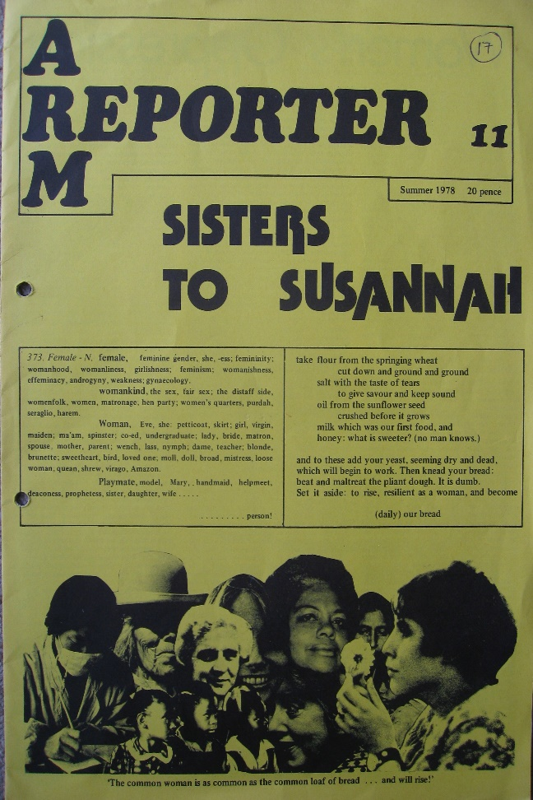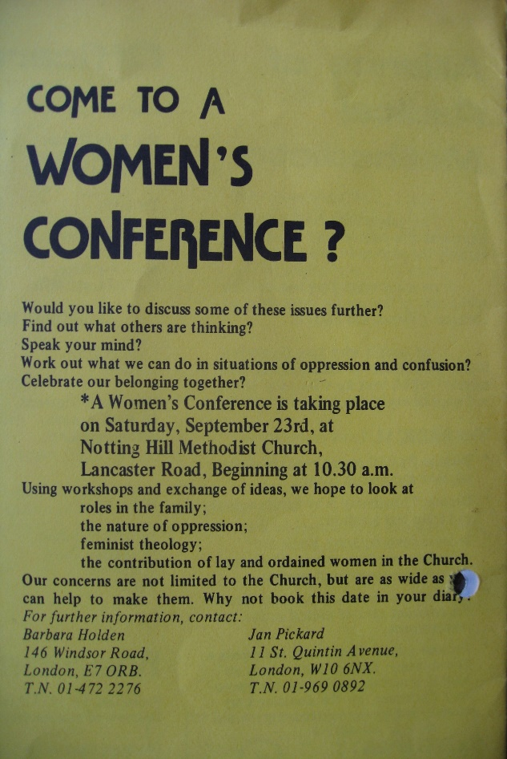

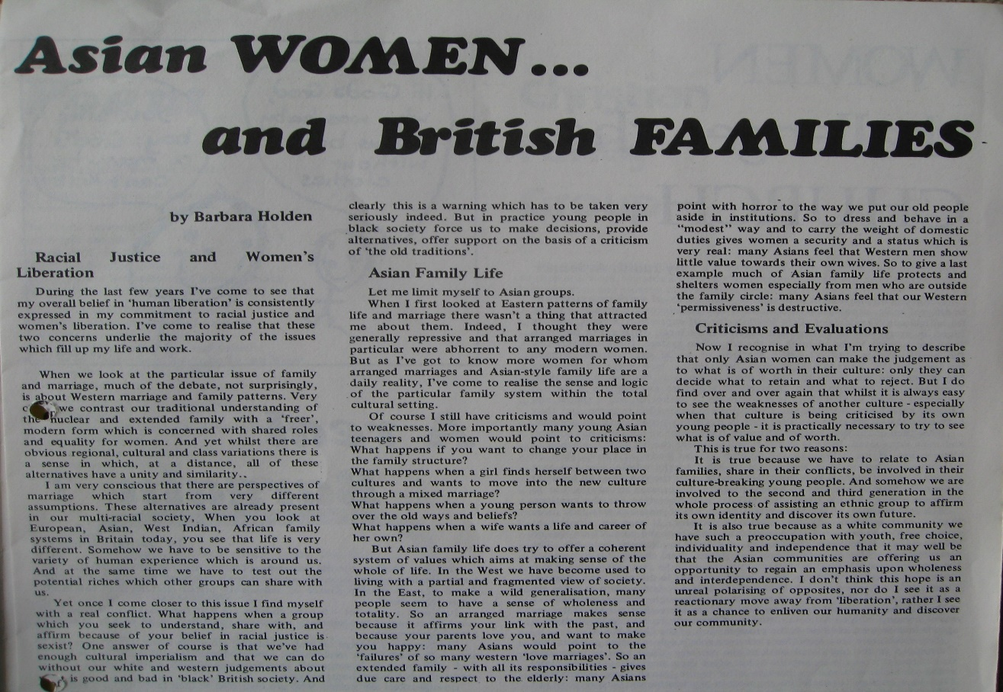

1972 Tony Holden - Turning the world upside down – Church Leaders’ Conference Birmingham
Back in 1972 I was involved in editing a daily news-sheet at a Church Leader’s Conference [see David L. Edwards ‘The British churches turn to the future: one man's view of the Church Leaders' Conference, Birmingham, 1972’].
Its title was ‘Upside down,’ from the words “these people are turning the world upside-down [Acts 17, 6]”
On the final day we produced seven slogans after an introduction paragraph that read: “This has been a ‘study-conference.’ We are glad that that we are not going to have agreed statements or resolutions to anyone. We hope that we have gained creative insights. We offer, very tentatively, something to take away which, rather like the Lund principle, may help us to move from very general ideas to specific lines of action.”
- Not to expect to know more until we’ve been obedient to what we know
- To live more simply that others may simply live
- To shift attention from the church’s struggle to survive to [people’s] struggle to be human
- To do nothing apart which can be done with the community
- Not to deal with people in crisis but to share in crisis with people
- To make decisions with others and not to take them on their behalf
- Not to confuse agreement with unity or certainty with faith

